Multi-Agent Framework for Automated Validation of Reporting Checklist Compliance in Observational Studies
Chenyu Li MS¹, Seohu Li BS², Yanshan Wang PhD¹, Michael J Becich MD PhD¹ ,Harold P Lehmann MD PhD²
¹University of Pittsburgh School of Medicine Department of Biomedical Informatics, PA,
²Johns Hopkins University School of Medicine Biomedical Informatics and Data Science, Baltimore MD
Introduction
Methodology checklists play a crucial role in evidence-based medicine by standardizing how research is reported and evaluated. These checklists are essential tools in the critical appraisal of evidence, helping clinicians and researchers assess the validity, applicability, and reliability of scientific findings¹. The EQUATOR (Enhancing the QUAlity and Transparency Of health Research) Network² was established to address the growing concern about inadequate reporting of research, providing a comprehensive repository of reporting guidelines including, STROBE for observational studies³, and RECORD for routinely collected health data⁴.
Despite the proliferation of these guidelines and their importance in evidence synthesis and clinical decision-making⁵, compliance remains inadequate. Approximately half of observational studies lack required checklists such as STROBE or RECORD. Surveys of authors indicate that time burden is the primary barrier to adoption⁶, highlighting a critical gap in implementation. Our previous work found similar challenges in real-world evidence studies based on electronic health records⁷. To address this gap, we developed a multi-agent framework leveraging complementary large language models (LLMs) that automates validation of research papers against reporting guidelines, potentially reducing a significant barrier to adoption while supporting more robust evidence appraisal.

Methods

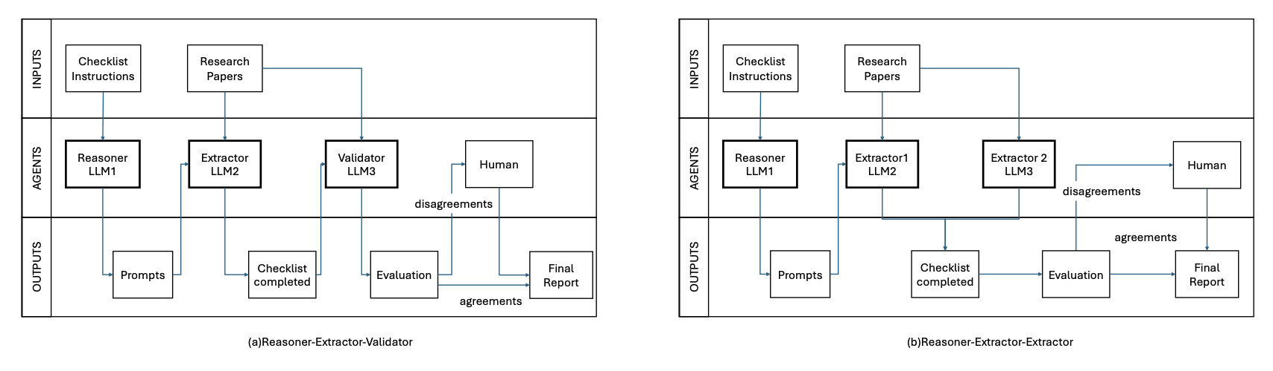
We designed a multi-agent cross-checking architecture (Figure 1) with two parallel implementations. Both begin with a reasoner agent (LLM1) that processes checklist instruction documents and generates structured extraction prompts, translating generic guideline requirements into targeted extraction instructions. In the Reasoner-Extractor-Validator approach (Figure 1a), an extractor agent (LLM2) identifies relevant content from research papers based on these prompts, followed by a validator agent (LLM3) that evaluates the extracted information against guideline requirements. In the Reasoner-Extractor-Extractor approach (Figure 1b), two different extractor agents (LLM2 and LLM3) work in parallel to identify information, with disagreements flagged for human review. Both approaches include cross-checking mechanisms that compare outputs from different LLM engines, overcoming potential biases inherent in single-model systems by exploiting complementary strengths of different LLMs throughout the validation process.
Figure 1Multi-Agent Framework Architecture
Our implementation features two distinct cross-configuration approaches for comprehensive validation. The primary Extractor-Validator approach combines different LLM engines, with Configuration A pairing OpenAI (GPT-4o) as the extractor with Anthropic (Claude-3.5-Sonnet) as the validator, and Configuration B reversing these roles. We also implemented an Extractor-Extractor approach that uses two different LLM engines as parallel extractors to measure inter-model agreement. To enhance system accuracy, we integrated retrieval-augmented generation (RAG) technology that extracts and chunks PDF text with overlapping segments, creates embeddings using VOYAGE AI's embedding model, performs semantic search to identify the most relevant text for each guideline item, and directs specialized LLM agents to process only these targeted sections.
We evaluated our system on 30 randomly sampled open-access observational studies from our previous research on observational research analytic quality evidence.⁷ In that prior work, we developed a Standard Operating Procedure (SOP) as a data extraction checklist similar to but more comprehensive than RECORD for observational studies analytic methods reporting. The Li Paper⁷ SOP was specifically designed to assess methodological quality in real-world evidence studies, with many items overlapping with established reporting guidelines. Our evaluation focused on 22 of the 35 total items from the Li-Paper SOP, specifically the methodological components (9-15, 20-33). We excluded metadata items (1-8) as these could be mapped through code-based metadata extraction, items with frequently missing data in our human-curated gold standard dataset (16-19), and specialized assessment items (34-35) that contained content repetitive with earlier checklist items on sensitivity analyses and computational phenotypes. Using the Li-SOP allowed us to leverage our previously validated gold standard dataset for framework evaluation while also assessing the system's adaptability to different reporting guidelines. This approach provided insights into both the framework's performance and its potential applicability to other standardized reporting checklists beyond the specific use case.

Results
As for Cross-Configuration Agreement, the Claude-OpenAI configuration showed a mean agreement rate of 88.33% (SD = 7.42%) compared to 87.58% (SD = 17.38%) for the OpenAI-Claude configuration. Statistical testing indicated no significant difference between configurations.
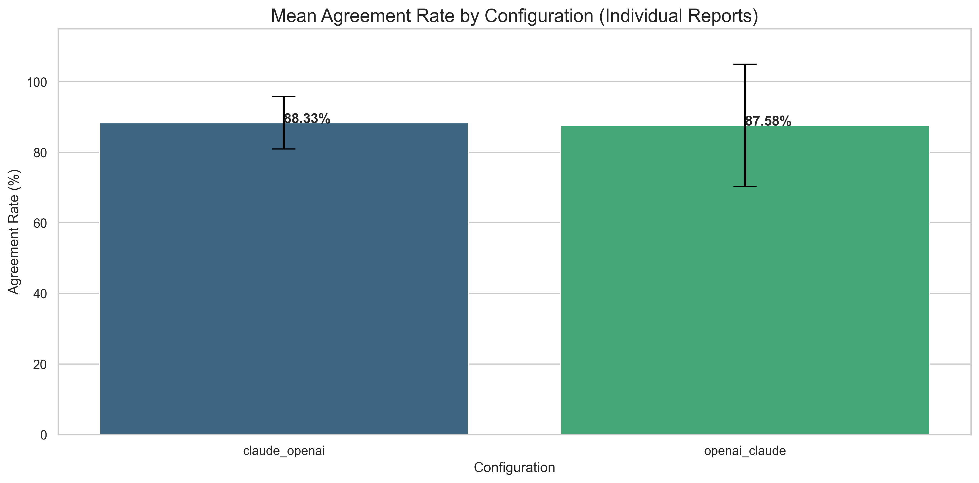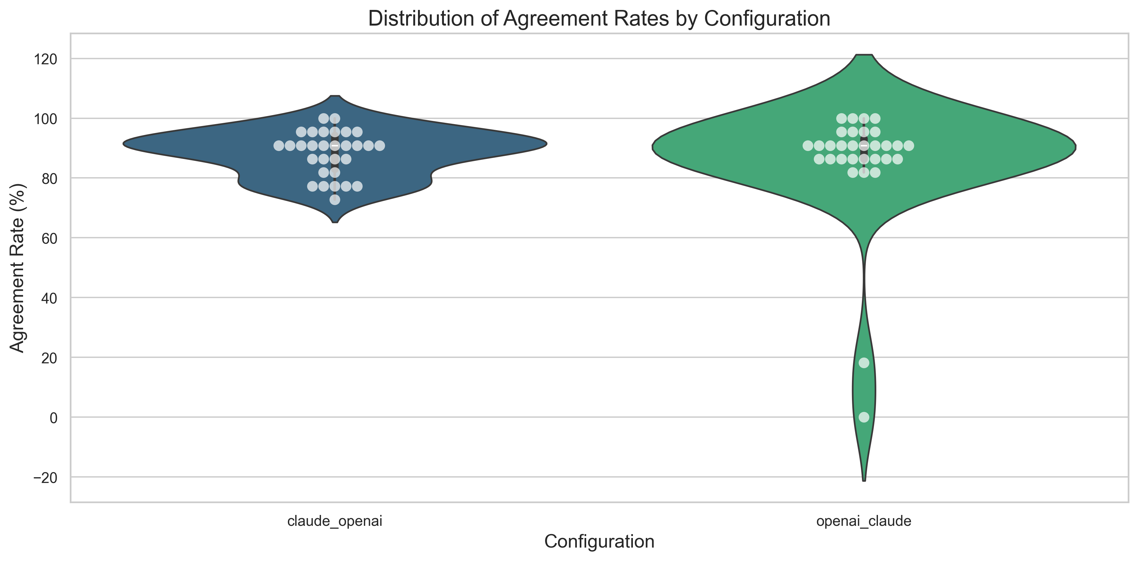
Figure 2 Cross-Configuration results

As for extractor-extractor architecture, the overall agreement rate calculated from human-evaluated extractor1 and extractor2 results was 92.58%, with only 49 disagreements out of 660 total items assessed. Items related to study design, data sources, and analytical methods consistently showed high agreement (>90%) across configurations, while items requiring subjective assessment showed more variability. Specifically, Item 15 (Analytical Goal) at 73.33% agreement, Item 12 (country/district) at 76.67%, and Item 31 (specify methods used in confounding analyses) at 76.67% demonstrated the lowest agreement rates across all checklist items. Agreement rates varied significantly across papers. Five papers (PubMed IDs: 20473188, 28472213, 34831722, 32964371, and 33175173) achieved perfect agreement rates of 100% across all checklist items, while the most challenging paper (ID: 32069337) had an agreement rate of only 72.73%. Automated processing required 3.8 minutes per batch when processing in parallel (with batch size set to 3 according to API request limits), compared to approximately 30 minutes per paper for manual review – representing a potential 95.8% time reduction when screening 300 papers.

Discussion
Our multi-agent framework addresses a significant barrier to reporting guideline adoption by drastically reducing assessment time while maintaining high accuracy. The cross-checking approach using different LLM engines enhances robustness by leveraging complementary model strengths. Items related to study design and analytical methods showed high agreement (>90%), while those requiring deeper interpretation and cross-sectional understanding demonstrated lower rates (73-77%), highlighting areas for improvement.
We evaluated the framework using Li-SOP checklist items rather than standard guidelines because we had established human-evaluated results from previous work. However, our architecture is checklist-agnostic and can process any reporting guideline provided as an instruction PDF, allowing potential support for all EQUATOR network checklists. Our implementation is available as open-source software with a web interface⁸.
In the future, the structured outputs could facilitate conversion to FHIR-based representations, enabling integration with evidence systems⁹. By addressing the time burden of checklist implementation, this approach could substantially improve reporting quality in observational studies, enhancing the reliability of research evidence for clinical decision-making.

References
1. Guyatt GH, Oxman AD, Vist GE. GRADE: an emerging consensus on rating quality of evidence and strength of recommendations. BMJ. 2008;336(7650):924-926. doi:10.1136/bmj.39489.470347
2. EQUATOR network. Accessed March 25, 2025. https://www.equator-network.org/.
3. von Elm E, Altman DG, Egger M, et al. The Strengthening the Reporting of Observational Studies in Epidemiology (STROBE) Statement: guidelines for reporting observational studies. Int J Surg. 2014;12(12):1495-1499. doi:10.1016/j.ijsu.2014.07.013
4. Benchimol EI, Smeeth L, Guttmann A, et al. The REporting of studies Conducted using Observational Routinely-collected health Data (RECORD) statement. Z Evid Fortbild Qual Gesundhwes. 2016;115-116:33-48. doi:10.1016/j.zefq.2016.07.010
5. Simera I, Moher D, Hirst A, Hoey J, Schulz KF, Altman DG. Transparent and accurate reporting increases reliability, utility, and impact of your research: reporting guidelines and the EQUATOR Network. BMC Med. 2010;8(1):24. doi:10.1186/1741-7015-8-24
6. Sharp MK, Glonti K, Hren D. Online survey about the STROBE statement highlighted diverging views about its content, purpose, and value. J Clin Epidemiol. 2020;123:100-106. doi:10.1016/j.jclinepi.2020.03.025
7. Li C, Alsheikh AM, Robinson KA, Lehmann HP. Use of recommended Real-World Methods for Electronic Health Record data analysis has not improved over 10 years. medRxiv. Published online June 22, 2023:2023.06.21.23291706. doi:10.1101/2023.06.21.23291706
8. Accessed March 25, 2025. https://github.com/ChenyuL/RWE_LLM_validator
9. Alper BS. EBMonFHIR-based tools and initiatives to support clinical research. J Am Med Inform Assoc. 2022;30(1):206-207. doi:10.1093/jamia/ocac193

Abstract
We developed a multi-agent framework using complementary large language models to automate validation of observational studies against reporting guidelines. Our system integrates a reasoner, extractor, validator, and cross-checking mechanism across different LLM engines (OpenAI gpt-4o, Anthropic claude-3.5) with retrieval-augmented generation. Testing on 30 papers showed high agreement rates (88-92%) between configurations and drastically reduced assessment time (95.8% reduction). This approach addresses the time burden barrier to guideline compliance while maintaining high accuracy, potentially improving research reporting quality.

